Title

Newzera landing website

Description of the problem

* Ensure that the website is responsive for both web and mobile versions.
* Improve the code efficiency.
* Update the homepage in Newzera landing according to new design.
* Make buttons and links functional with dummy internet links.

Functional requirements

* Switching to mobile version based on screen width.
* Extract frequently used components and enforce code reusability.
* Implement clicking of the button and icons with internet links.
* The homepage design should be responsive according to different viewport sizes.

Non-functional requirements

The required attributes to determine the standards or quality of the system go here.

Non-goals

Integrating the backend.

Assumptions

The current code has implemented the design with precision and there aren’t any minor discrepancies.

Risks

If there are any unknowns or potential risks, they should be listed here. Are there any open questions for which you do not have answers currently? They should be included here.

Solutions - all including considered and discarded

All the solutions to the problem go here.

* Using bootstrap to design the web components. Discarded because mobile and web components are totally different so there is no need for it.
* Extracting components like Modal, Sidebar, etc. which are currently being defined in each and every component and other code segments are redundant.

System Design

* **System architecture**

Explain the system architecture and its working.

* **Modules**

All the Pages are affected by these new components.

External dependencies

Describe the external libraries or packages used (if any).

Internal dependencies

List the unit components or assets that have been used as a part in this project.

Planning

* Scan the code completely for the code segments that have redundant and repeated code and unnecessary comments.
* Extract the views to separate components in a SharedComponents directory.
* Check for all the occurrences of the view and replace those occurrences with the new simplified component.
* Make the component dynamic with props so that it is easily reusable not only for the current components but also for the future components.
* Make the buttons and links functional with dummy internet links.
* Deploy the website.
* Go through the current frontend part of newzera landing homepage and check for the changes to be made on it.

Deliverables

Newzera landing website frontend, ready to be deployed.

User Interface

The images or screenshots of the developed flows go here.

* Newzera landing homepage -

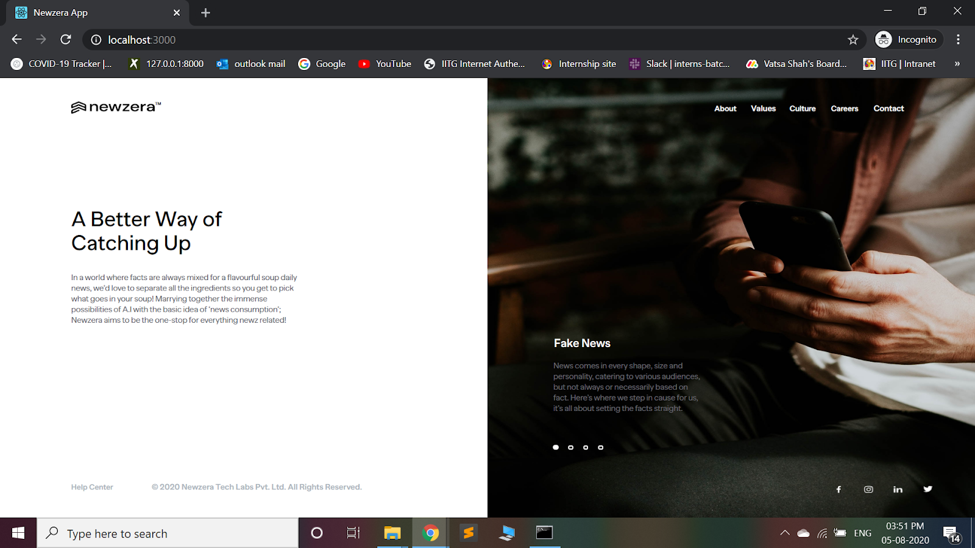

Test plan

It goes without saying that all code should have good tests run on the waterfall. You don’t need to write about that.

Here is where you should write how you are planning to test the components, flows. What parameters will be considered to test? Also describe what the test team may need to consider before approving your launch. Give any directions needed to exercise your feature. Call out any special platforms conditions that may require extra attention.

Milestones

* Make the code more efficient and readable.
* Make the web pages dynamic upto some extent.
* Deploy the Newzera Landing website frontend.

Follow up work

Integration with the backend and solving issues that arise thereon.